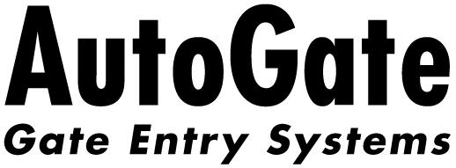
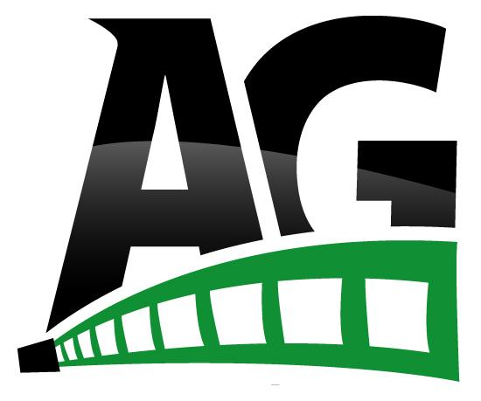®
7306 Driver Road ● P.O. Box 50
Berlin Heights, OH 44814
Ph. 419.588.2796 Fax: 419.588.3514
To: All AutoGate Employees
From: Bill & Don
May 1, 2020

Thank you to all of you who have helped us get through the past six weeks. A pandemic of this magnitude is something that has been challenging and difficult to navigate, and though we have had to change course throughout this time, we certainly appreciate your cooperation and understanding. Unfortunately, the Covid-19 will be around for a while which has prompted many federal and state regulations for how businesses should operate during this time.

Beginning Monday, May 4, businesses and manufacturers can reopen or operate with some new additional guidelines. We were fortunate to have some foresight and anticipated that changes were inevitable, so we put many of these in place prior to latest recommendations which allowed us to partially remain open. The practices that we have started will continue to be a regular part of the workday until further notice, but there have been a few changes and additions in order to allow Ohio to reopen. Listed below are the current items:
- Ensure minimum 6 ft between people, if not possible, install barriers
- Employees must perform daily symptom assessment*
- Require employees to stay home if symptomatic
- Face coverings should be worn when the 6 ft distance cannot be maintained.
- Employees should carry a face covering with them
- Require regular handwashing
- Stagger or limit arrivals of employees and guests
- Personnel should work from home if possible
Prior to this date, we have had many of these procedures and protocols in place so the acclimation should be an easy one; however, we have not required the use of face coverings until now. This is not something specific to the production floor personnel only; it does apply to office personnel also.

Many things that are being asked of all employees are highly unusual and would normally not occur if we were not amid a public health crisis. We do understand and empathize with you regarding how these face coverings can be somewhat uncomfortable and get warm easily, but this is something that must be followed in order for us to remain compliant and open. Not following this directive can subject the employee to disciplinary action as well as have some unfavorable ramifications for AutoGate.

There is no definite timeline to how long these safe hygiene practices will be necessary. Our hope is to be able to relax them as soon as possible in a responsible manner.

Please see Jim Mongiardo if you need a cloth face covering. Questions should be directed to Diane or Wendy in Human Resources.

Thank you,

Bill Don

Bill Rodwancy Don Rodwancy
CEO & President Vice President

